NEXTAG COMPANY

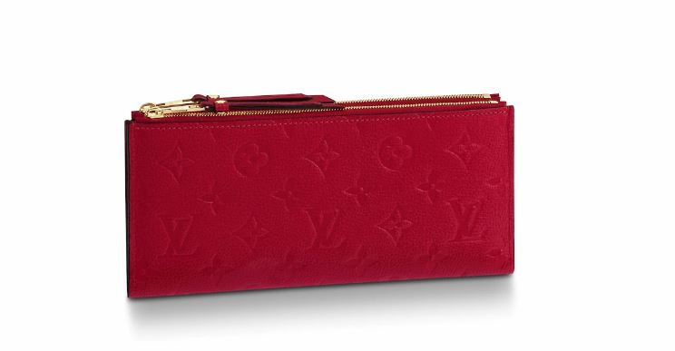LOUIS VUITTON - ADÈLE WALLET

##### **Detail**

Crafted from embossed Monogram Empreinte leather, the elegant Adèle Wallet has an ultra-slim design with two leather zips and a magnetized button for easy opening. Roomy enough to hold a smartphone in addition to cards and coins, it can also be carried as a clutch.

• Scarlet Red

• Monogram Empreinte embossed supple grained cowhide leather

• Supple grained cowhide-leather trim

• Grained cowhide-leather lining

• 22.0 x 10.0 x 1.5 cm (Length x Height x Width)

##### **CARE & COMPOSITION**

* leather
* imported